**ADMIN PORTAL**:

**LOGIN PAGE:**

1. Without enter Email ID and click forgot password button, user is not registered error pop up is displayed.
2. Reset password page, need to add eye icon to see the entered password.
3. Reset password page, need to change the error text properly.

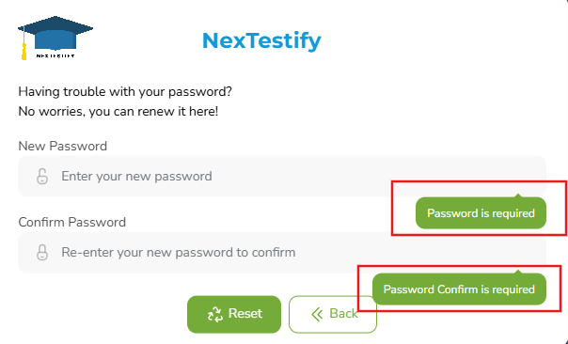

**ADMIN**:

1. When enter max characters in first and last name field, username is not properly displayed.

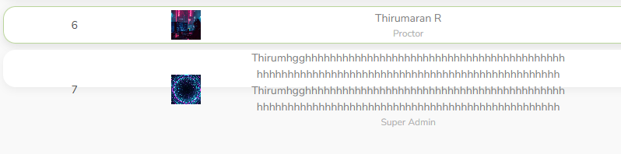

1. Need to remove scroll option in admin page. Coz, currently we have 7 users only, so need to remove the scroll function.
2. In grid, 1st page display 9 users and 2nd page starts from 11th user.

**Create Questions**:

1. When try to search the question name in the search box and again erase the question, but the page display the same question only remaining questions are not displayed.

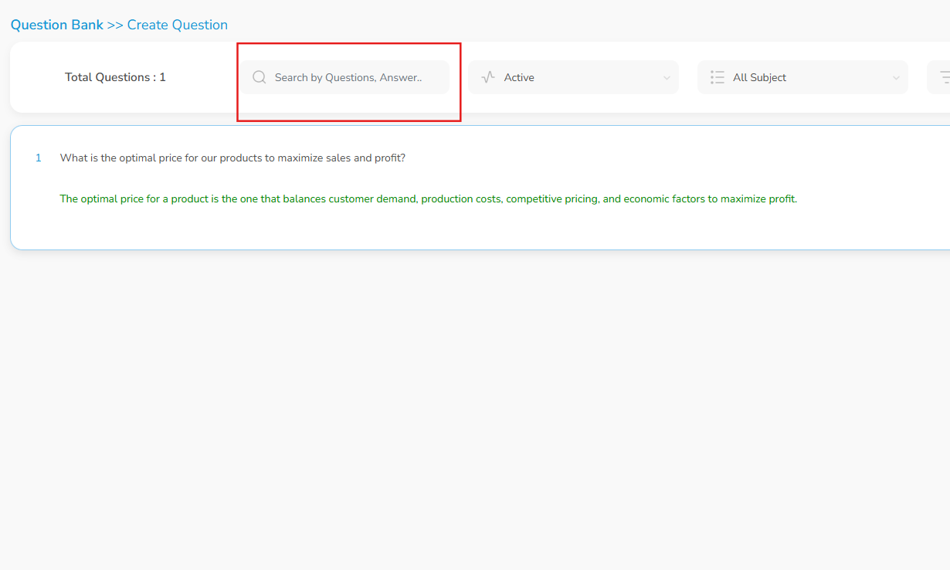

1. Question Level filter is not working.
2. Create Question- Without enter any thing and click save button, red border is displayed and when user click clear button border is not removed.
3. Create Question- In add topic popup, Without select subject name and click add button mandatory message should display in topic tab only not in subject tab.
4. Create Question- In add topic popup, When perform drag and drop of invalid file in image or any other tab, "Invalid Format" message is displayed but the file is alredy in the tab and try enter all other valid details and click save button, "Something went wrong" erroro message is displayed.
5. Create Question- in points and time tab, User able to enter alpha and special characters
6. Create Question- After enter valid details and click save button, Question cannot able to save and display "Something went wrong" error message.
7. Create Question- Select “Essay” question type and enter valid details and select any other question type, previous entered details are not cleared.
8. Edit Question-Uploaded file names are not displayed.
9. Edit Question-After delete the uploaded file and click update button, uploaded image is not removed in the page.

**TEST SETUP:**

1. New Test-For proctoring capacity, User can able to enter more than max characters. Need to fix the maximum characters.
2. New Test-Time Setup-Need to change the text “All times are in the "Asia/Kolkata" timezone.” and enter any other valid message.
3. New Test-Time Setup-User can able to select past time details in the calendar.
4. New Test-Test Access-When click select all checkbox button, all candidate name is not selected.